**HOW TO USE FILEZILLA**

1. Execute file filezilla.exe

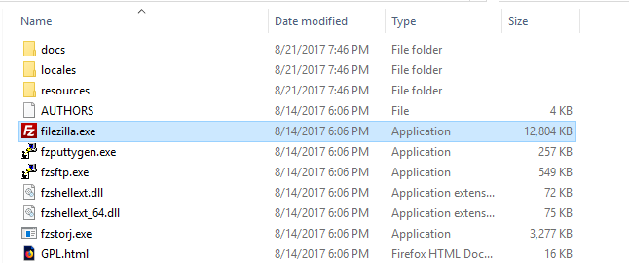

1. Filezilla window appears

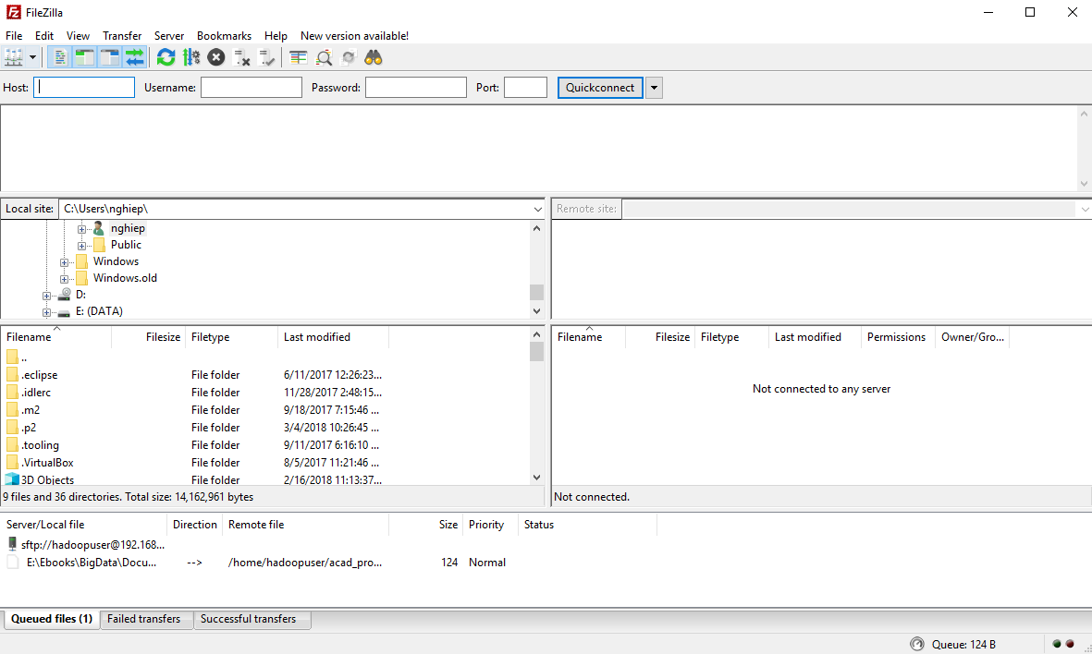

1. Select **File -> Site Manager…**

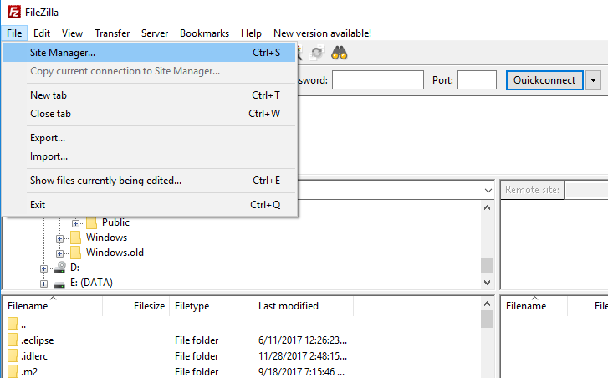

1. Click on **New Site** and enter site name

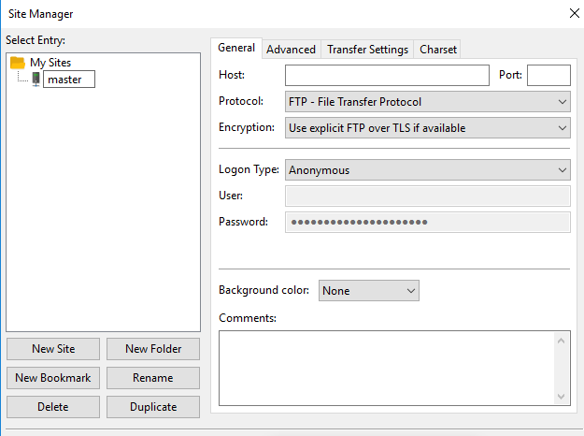

1. Enter **Host** to access. Select Protocol **SFTP – SSH File Transfer Protocol.** Select Logon Type **Normal.** Then enter User and Password

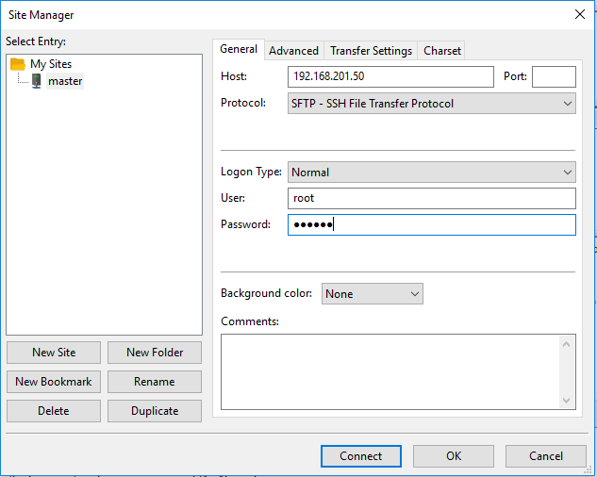

1. Click **Connect**

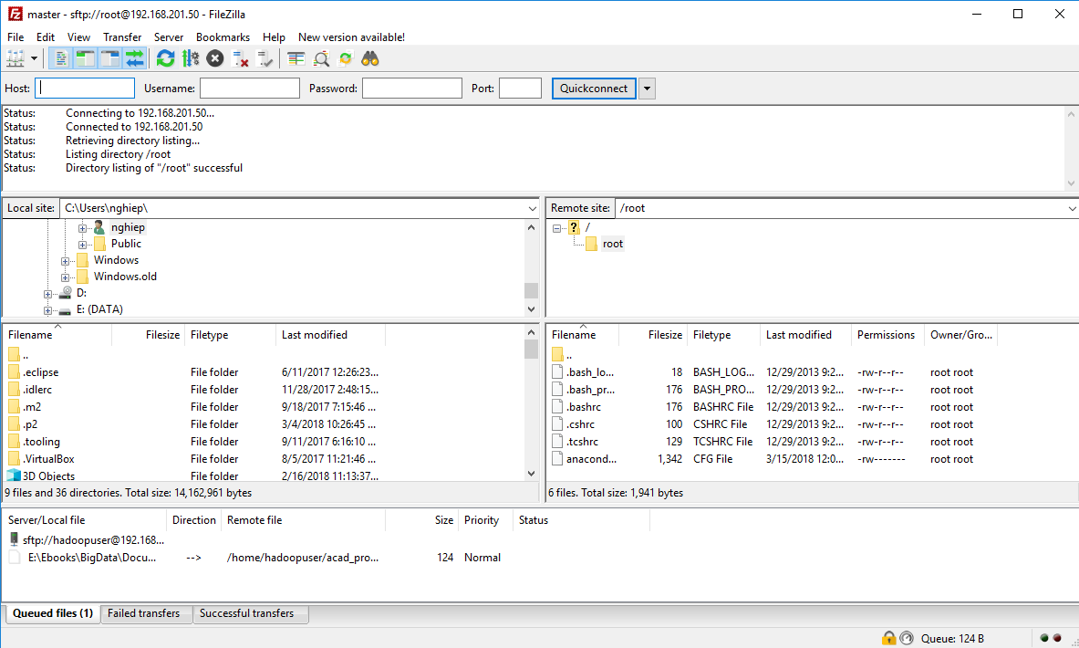

1. Drag files from Windows OS to Linux

